Shobhit Bhatnagar

A Tool for tracking and managing the Month wise Minor Enhancement Tasks through a proper workflow

Minor Enhancement Tracking Tool

Technical Documentation

Table of Contents

1. Introduction 2

1.1. Background and Objective of this Application 2

1.2. Stakeholders 2

1.3. Technical Stack: MEAN Stack 3

1.3.1. Microsoft SQL Server: 3

1.3.2. .NET Core: 3

1.3.3. Angular.js: 3

2. Requirements of the Application 4

2.1. Brief Description 4

2.2. Process Flow 4

2.3. E-R Diagram 4

2.4. Wireframes 5

## Introduction

## Background and Objective of this Application

Currently NSDC IT team is tracking and monitoring the Monthly Minor Enhancements over mails and excel sheet. Also business is raising all the requests for enhancements through emails in different formats which not easy to track and manage. To overcome this situation and make the process more efficient and robust with a proper workflow of Request – Evaluate – Approval the NSDC IT team is now developing an application namely **Minor Enhancement Tracking** (MET) tool.

## Stakeholders

This tool has majorly 3 types of Stakeholders:

* **Business Users / Requester**: The Business users / Requesters will be the one who will raise a request on MET for a minor enhancements in any of the modules and will submit their detailed requirements for the enhancement as well through a UI interface on MET. Also, the business user can check the updates on development & deployment of the enhancement through MET.
* **Development Team:**  The Development team will be the one to evaluate the requirement and provide a tentative efforts for the same on MET. Also post approval of the final efforts the development team will be responsible for the development and deployment of the enhancement and uploading the Release Note with the date of moving this to production on MET.
* **UAT Team:** The UAT team will be the one to do the Quality & Functional testing of the development and provide confirmation from business that development is as per the requirements in the request. Also post UAT the UAT team will mention the start date of UAT and sign off dates with business sign off mails. Post UAT the request will again go to development team for production movement.
* **IT Team:**  The IT team will be reviewing the effort estimation provided by the development team and post discussion and negotiations the IT team with enter the final efforts estimation for an enhancement and will give the go ahead to the development team. IT team will be able to view analytical dashboard such as below:
  + Monthly Total Minor Enhancement efforts
  + Monthly Department wise Minor Enhancement efforts
  + Monthly Module wise Minor Enhancement efforts
  + Time-lag in providing Effort estimation
  + Time-lag in approving Effort estimation
  + Time-lag in development post approval of Efforts

## Technical Stack: MEAN Stack

For the designing of the UI and development of client interface the AngularJS version 9 (or Angular 9) is used with multiple third-party package. Angular JS is a free and open-source JavaScript software stack for building UI of dynamic web sites and web applications.

The architecture is complete secured micro service-based application, as Angular interacts with .NET API serve through Token based Authenticated APIs.

Further the backend API serve is developed on .NET Core 2.2 framework has been used which further interacts with the database server MS SQL Server in production environment and SQL Lite in development environment.

## Microsoft SQL Server:

Microsoft SQL Server is a relational database management system developed by Microsoft. As a database server, it is a software product with the primary function of storing and retrieving data as requested by other software applications—which may run either on the same computer or on another computer across a network (including the Internet).

## .NET Core:

.NET Core is a free and open-source, managed computer software framework for Windows, Linux, and macOS operating systems. It is a cross-platform successor to .NET Framework. The project is primarily developed by Microsoft employees by way of the .NET Foundation, and released under the MIT License.

## Angular.js:

Typically data is fetched using Ajax techniques and rendered in the browser on the client-side by a client-side application framework, however as the stack is commonly entirely JavaScript-based, in some implementations of the stack, server-side rendering where the rendering of the initial page can be offloaded to a server is used so that the initial data can be prefetched before it is loaded in the user's browser.

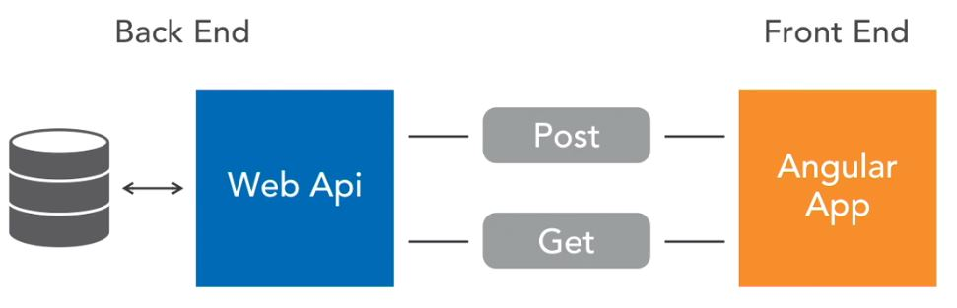

## Requirements of the Application

## Brief Description

## Process Flow

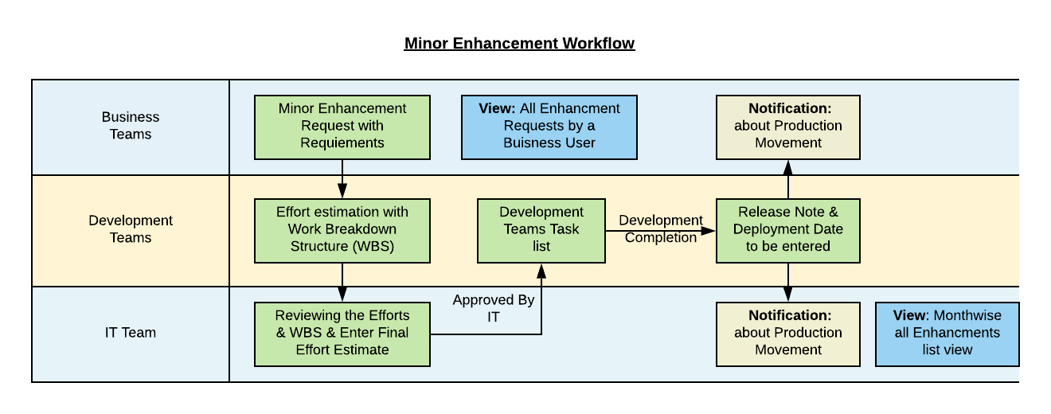

## E-R Diagram

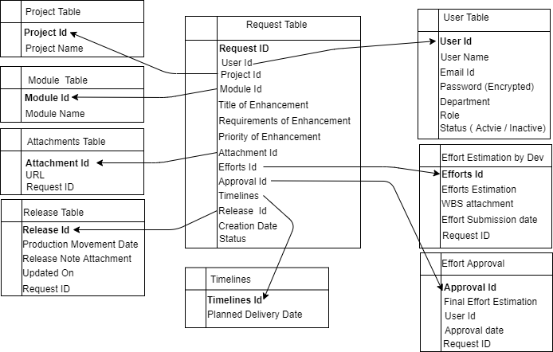

## Wireframes